 | KNN | SVM
Training Speed | ~ 0.5 -1.5 min | ~ 12 - 19 min
preprocessing | Use scaler(normalizer), pca | scaler(standard scaler)
Feature extraction | Hand-crafted (HOG, LBP, Color Histograms)  And then combine them into one histogram  And then use PCA to shrink high variance | Deep Learning Features (VGG16 Embeddings)  Model learned how to recognize complex patterns and we took the last layer which in 512 vector
Threshold used | 0.6 | 0.44
Parameters | n_neighbors =5  metric = ‘eucledian’ | C= 100,  kernel=’rbf’,  class_weight =’balanced’
memory | Store the entire training set | Only stores support vectors
Accuracy | - On Augment on whole data : 0.86  - When augment on only training data : 0.59  - When improving feature extraction (changing hyper parmeter and model parameter) : 0.63  - After Using CNN on feature extraction : 0.86 | - On Augment on whole data : 0.84  - When augment on only training data : 0.55  - When improving feature extraction (changing hyper parmeter and model parameter) : 0.67  - After Using CNN on feature extraction : 0.85

Final Improved KNN Accuracy :
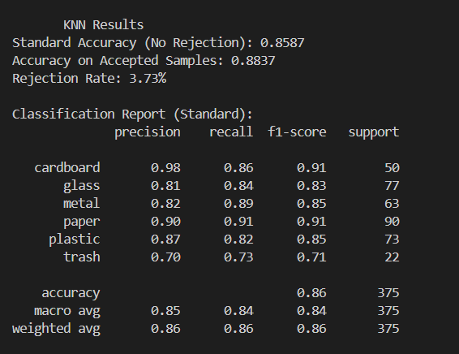

Final improved SVM Accuracy:
